Lecture 3.2.4
Euler and Hamiltonian Path
Course outcome to be covered:
CO3: Apply and recognized about the Graph Theory

1.1 Topic Objectives:
- Determine whether a graph has an Euler path and/ or circuit
- Add edges to a graph to create an Euler circuit if one doesn’t exist
- Identify whether a graph has a Hamiltonian circuit or path

1.2 Introduction:
In this lecture, we will investigate specific kinds of paths through a graph called Euler paths and circuits. Euler paths are an optimal path through a graph. They are named after him because it was Euler who first defined them.
By counting the number of vertices of a graph, and their degree we can determine whether a graph has an Euler path or circuit. We will also learn another algorithm that will allow us to find an Euler circuit once we determine that a graph has one.

1.3 Euler Path

An Euler path is a path that uses every edge in a graph with no repeats. Being a path, it does not have to return to the starting vertex
In the graph shown below, there are several Euler paths. One such path is CABDCB. The path shown in arrows to the right, with the order of the edges numbered.
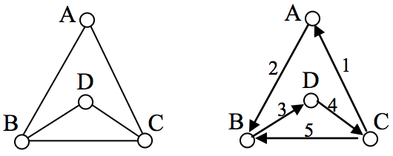
Euler Circuit:
An Euler circuit is a circuit that uses every edge in a graph with no repeats. Being a circuit, it must start and end at the same vertex.

The graph below has several possible Euler circuits. Here’s a couple, starting and ending at vertex A: ADEACEFCBA and AECABCFEDA. The second is shown in arrows.

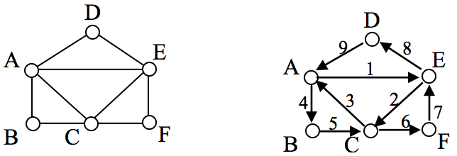

EULER’S PATH AND CIRCUIT THEOREMS:
- A graph will contain an Euler path if it contains at most two vertices of odd degree.
- A graph will contain an Euler circuit if all vertices have even degree
Euler Graph:
An Euler Graph is a graph that possesses a Euler Circuit. A Euler Circuit uses every edge exactly once, but vertices may be repeated.

Example – Which graphs shown below have an Euler path or Euler circuit?
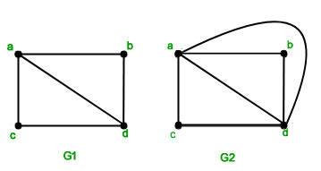
Solution – G₁ has two vertices of odd degree a and d and the rest of them have even degree. So this graph has an Euler path but not an Euler circuit. The path starts and ends at the vertices of odd degree. The path is a, c, d,a, b,d
G₂ has four vertices all of even degree, so it has an Euler circuit. The circuit is –
a, d, b, a, c, d, a
Example: The graph shown in fig is a Euler graph. Determine Euler Circuit for this gr.
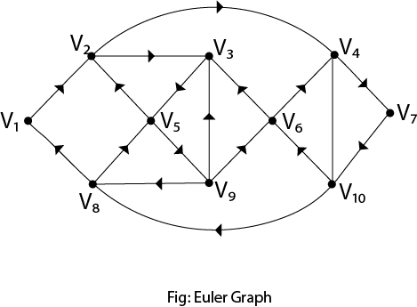
Solution: The Euler Circuit for this graph is
V₁,V₂,V₃,V₅,V₂,V₄,V₇,V₁₀,V₆,V₃,V₉,V₆,V₄,V₁₀,V₈,V₅,V₉,V₈,V₁
We can produce an Euler Circuit for a connected graph with no vertices of odd degrees.

Theorem – “A connected multigraph (and simple graph) with at least two vertices has a Euler circuit if and only if each of its vertices has an even degree.”

Proof: every time a circuit passes through a vertex, it adds twice to its degree.
Since it is a circuit, it starts and ends at the same vertex, which makes it contribute one degree when the circuit starts and one when it ends.
In this way, every vertex has an even degree.
Since the Koningsberg graph has vertices having odd degrees,
an Euler circuit does not exist in the graph.

Theorem – “A connected multigraph (and simple graph) has an Euler path but not an Euler circuit if and only if it has exactly two vertices of odd degree.”

Proof: The proof is an extension of the proof given above. Since a path may start and end at different vertices, the vertices where the path starts and ends are allowed to have odd degrees.
Hamiltonian paths and circuits :

Hamiltonian Path – A simple path in a graph that passes through every vertex exactly once is called a Hamiltonian path.

Hamilonian Circuit – A simple circuit in a graph that passes through every vertex exactly once is called a Hamiltonian circuit.

Example: Does the following graph have a Hamiltonian Circuit?
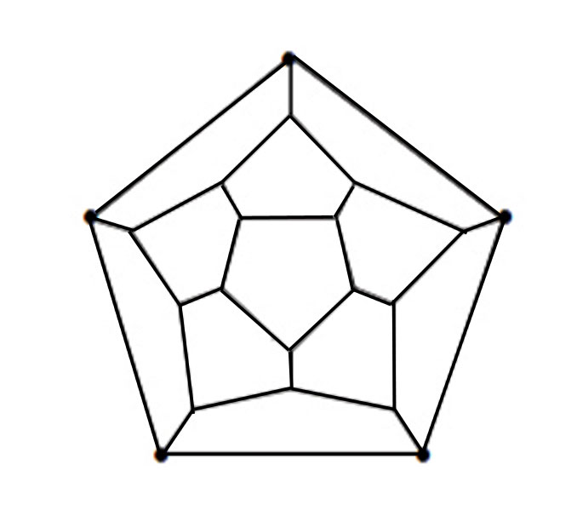
SOLUTION:
Yes, the above graph has a Hamiltonian circuit. The solution is –
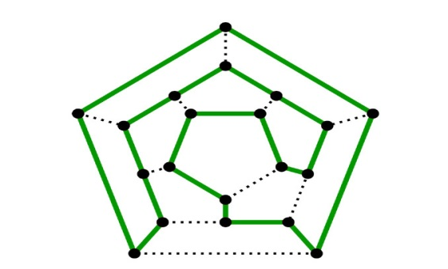

Some Areas of Application:

- Networks can be used to solve many difficult problems, like the Konigsberg Bridge Problem

- It can also be used to by mail carriers who want to have a route where they don’t retrace any of their previous steps.

- Euler circuits and paths are useful to painters, garbage collectors, airplane pilots and all world navigators
Practice Questions
  - Eulerize the graph shown, then find an Euler circuit on the Eulerized graph.
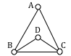
  - Does the following graph have a Hamiltonian Circuit?
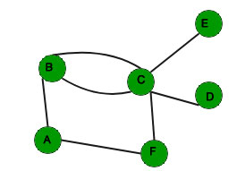
FAQ
Q.1 Is every path a circuit?
Ans: Is every path is a circuit? No, because not every path ends at the same vertex where it starts.

Q.2 What is the difference between Euler circuit and Hamiltonian circuit?
Ans: An Eulerian circuit traverses every edge in a graph exactly once, but may repeat vertices, while a Hamiltonian circuit visits each vertex in a graph exactly once but may repeat edges

Summary
In this lecture, we have discussed about
- Euler Path and circuits
- Hamiltonian Path and circuits
- Various examples related to Euler path and Hamiltonian path
REFERENCES
Books
[1] Elements of Discrete Mathematics, (Second Edition) C. L. Liu, McGraw Hill, New Delhi, 2017
[2] G. Ronald, Knuth, Donald and Patashik Oren, concrete Mathematics: A Foundation for Computer Science", Addison-Wesley.
Websites
[1] https://www.geeksforgeeks.org/graph-theory-gq/
[2] https://courses.lumenlearning.com/waymakermath4libarts/chapter/euler-circuits/
[3] https://www.javatpoint.com/regular-and-bipartite-graphs
Courses
[1] https://www.coursera.org/specializations/discrete-mathematics
[2] https://www.classcentral.com/course/swayam-discrete-mathematics-12929
Video Links
[1] https://youtu.be/5M-m62qTR-s
[2] https://youtu.be/xR4sGgwtR2I

